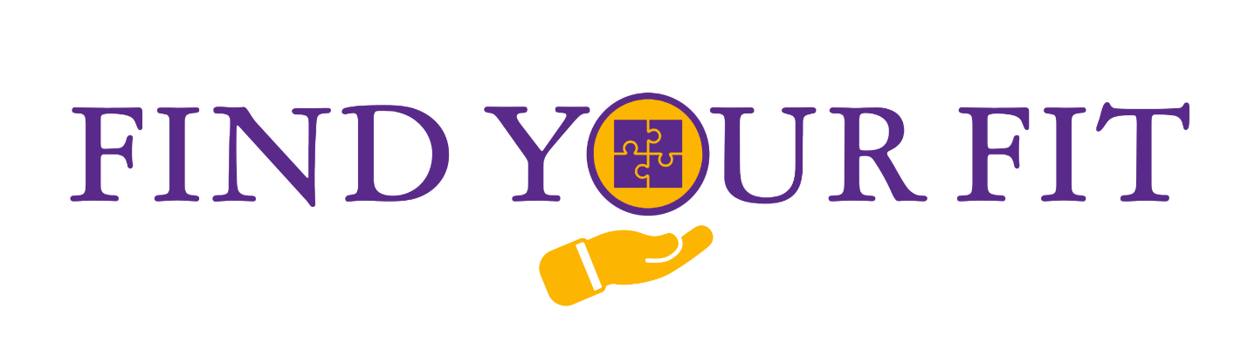

New Faculty Orientation 2025 - Newsletter #5

This week’s newsletter has a sneak peek of some of our NFO sessions, as well as information on the ECU Center for Communication Excellence. You’ll learn how to get started in Canvas and how to incorporate the UDL principle of multiple means of engagement into your courses. If you’re a sports fan, check out the information about all of the athletic teams at ECU!  - NFO 2025 Team | Find Your Support:  Center for Communication  Excellence  Find Your Way:  Overview of NFO Sessions  Introduction to Canvas  Prepare Courses in Canvas  Find Your Spot:  ECU Athletics  Find Your Purpose:  Multiple Means of Engagement (UDL)

New Information for July 3:
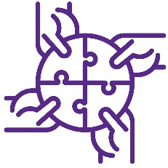 |  | Find Your Support: Center for Communication Excellence  Looking to strengthen your communication skills? ECU’s Center for Communication Excellence (CCE) is here to help you become a more confident and effective communicator. Located in 205 Joyner East on the Main Campus, the Center offers support with everything from class presentations and interview preparation to presenting research concisely, PowerPoint design, leadership development, and navigating difficult conversations.  Whether you prefer one-on-one help or group sessions, the Center provides both in-person and virtual consultations to fit your schedule.  Want to see what the Center for Communication Excellence is all about? Watch the video below!  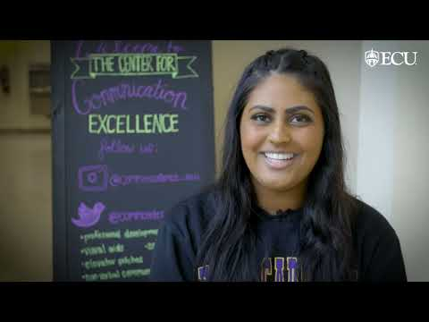
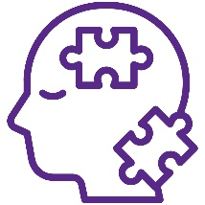 |  | Find Your Way #1: Overview of NFO Sessions  Getting excited for New Faculty Orientation? Here’s a sneak peek at some featured sessions during New Faculty Orientation (NFO):  Welcome from Senior Administrators: Kick off your first day by hearing directly from ECU’s senior leadership. You’ll start the morning with brief remarks and have a chance to connect more personally during the Chancellor’s Welcome Reception that evening.  From Our Students: This is one of our most popular sessions! Hear directly from current undergraduate and graduate students as they share classroom insights, tips, and takeaways based on their most memorable learning experiences.  Information Fair: Meet representatives from more than 30 ECU offices and community organizations that collaborate with faculty on teaching, research, service, and regional engagement. It’s a great way to explore campus and community resources. Look for more details about some of these resources in upcoming newsletters!  Breakout Sessions: Customize your experience by choosing from a variety of topics, including faculty well-being resources, the University Writing Program, Global Affairs, and community engagement.  Faculty Panels: Learn from experienced tenure-line and fixed-term faculty as they share advice on navigating evaluation, reappointment, advancement, promotion, and everything in between. This is a great opportunity to hear what starting at ECU is really like, from those who’ve been there.  
Help us put all the pieces in place! If you haven’t filled out the NFO 2025 Survey, please complete it so we can plan for August!

Find Your Way #2: Introduction to Canvas

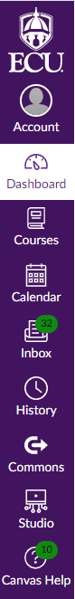
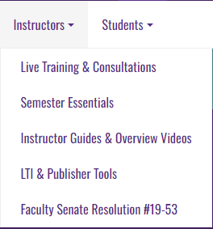
Canvas is ECU’s primary learning management system. You can access and manage your account on the page linked above, where you'll find your dashboard, courses, notifications, and more. It is your central hub for organizing and delivering course content.

Canvas offers a range of resources to help you get started and make the most of the platform. You’ll have access to live and recorded training sessions, one-on-one consultations, and 24/7 live chat support. Built-in tools and guides can also help your students navigate the platform successfully.

Some faculty in the Brody School of Medicine may use the VidaNova learning platform. Like Canvas, VidaNova is supported by a robust set of tutorials and resources to help you teach effectively.

Find Your Way #3: Prepare Courses in Canvas

The first day of classes will be here before you know it, and it's never too early to get started on your Canvas resources! Get underway using this guide for Canvas Semester Essentials.

ECU also offers a wide variety of Canvas instructor guides, a self-paced “Getting Started with Canvas” course, and comprehensive training through LinkedIn Learning.

Need additional support? You can register for additional training or book a consultation with a Canvas expert. You can access 24/7 assistance through Canvas Help. Just log in to Canvas and start a live chat.
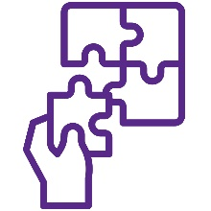 | Find Your Spot: ECU Athletics  With 14 men’s and women’s teams, ECU Athletics has something for every sports fan, from baseball and basketball to volleyball and beyond. Want to learn more about the teams, meet the players, or grab tickets? Visit ECU Athletics for the latest updates and schedules.  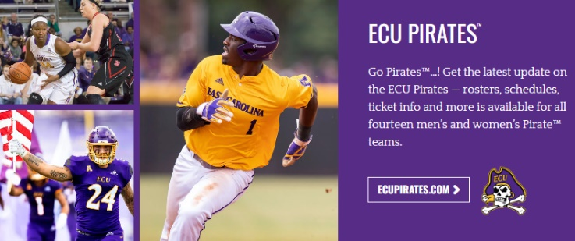
 |  | Find Your Purpose: Multiple Means of Engagement (UDL)  Hear from Justin Littlefield again as he explores one of the core pillars of UDL: Multiple Means of Engagement.  Staying focused on clear goals is essential for fostering engagement. In the video below, Justin explains how sharing the purpose behind each course module and assignment helps students stay motivated and on track. He also emphasizes a central aim of UDL: supporting students in becoming expert learners.  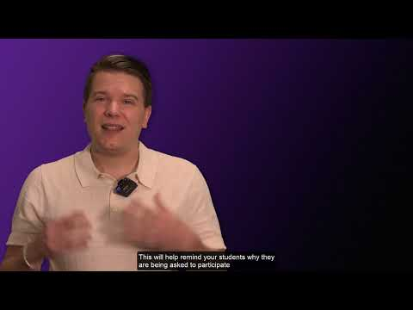
Directions to websites in this newsletter:
- Center for Communication Excellence
- New Faculty Orientation Information Survey Link
- Canvas
- VidaNova
- Canvas Semester Essentials
- Canvas Instructor Guides
- Getting Started with Canvas
- LinkedIn Learning Canvas Training
- Book a Canvas Consult
- ECU Athletics
- UDL: Multiple Means of Engagement

You can visit the NFO 2025 Find Your Fit website to view the newsletters released each week, as well as access previously released content.
Please reach out if you have any questions by replying to this email or emailing ofe@ecu.edu. Stay tuned for next week’s newsletter!
-The New Faculty Orientation (NFO) 2025 Team!

