

New Faculty Orientation 2025 - Newsletter #4

This week’s newsletter has descriptions of the many recreation facilities at ECU and some of the most loved travel destinations just a short drive from Greenville. You’ll also get information about the Canvas Connections series, how to purchase a parking permit, registering for ECU Alerts, downloading LiveSafe, and how to map out your mentors for a successful career at ECU!  - NFO 2025 Team | Find Your Support:  Recreation and Wellness  Find Your Way:  Canvas Connections  Parking Permits  ECU Alerts and LiveSafe  Find Your Spot:  Popular Day Trips  Find Your Purpose:  Mentoring at ECU

New Information for June 26:
 | Find Your Support: ECU Recreation and Wellness  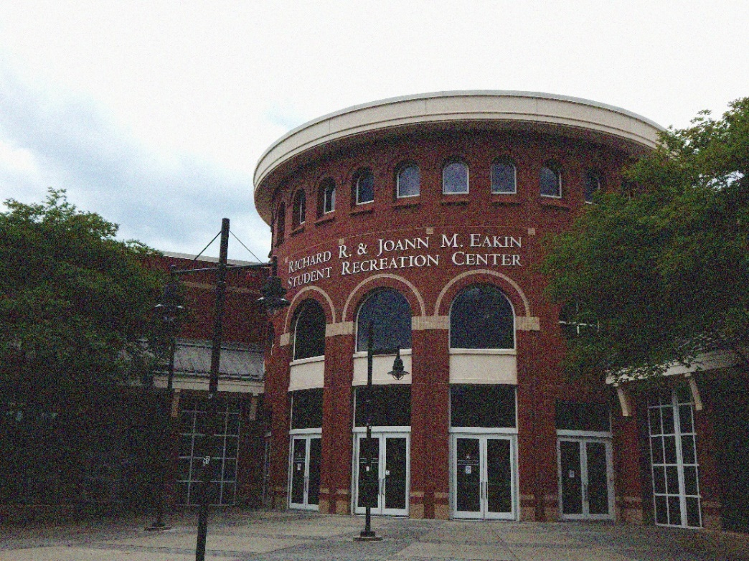  Looking for ways to stay fit, have fun, and connect with others? ECU’s Campus Recreation & Wellness (CRW) has everything you need to stay moving! Check out the Eakin Student Recreation Center on the main campus, explore the Health Sciences Campus Recreation Center, or head outdoors to the North Rec Complex or Blount Rec Sports Complex. They are all just a short trip away!  From energizing group fitness classes to state-of-the-art weight rooms, an indoor track, and a climbing wall, the Eakin Student Recreation Center is a hub of activity in the heart of campus.  Want a closer look? Justin Waters from CRW and Sarah Williams from the OFE take you on a behind-the-scenes tour in the video below. You can also visit in person and ask any CRW staff for a tour of the facility!  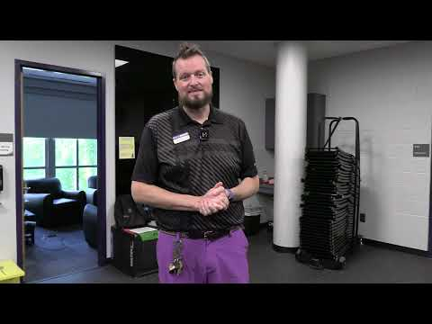  The Health Sciences Campus Recreation Center is a modern facility that features small group training, cross-training spaces, courts for basketball and volleyball, free weights, and more. You can even take a virtual tour!  Just a short drive from campus, the North Recreational Complex (NRC) offers expansive activity fields, 19-hole disc golf, walking and jogging trails, and plenty of green space to relax or get a game going with friends.  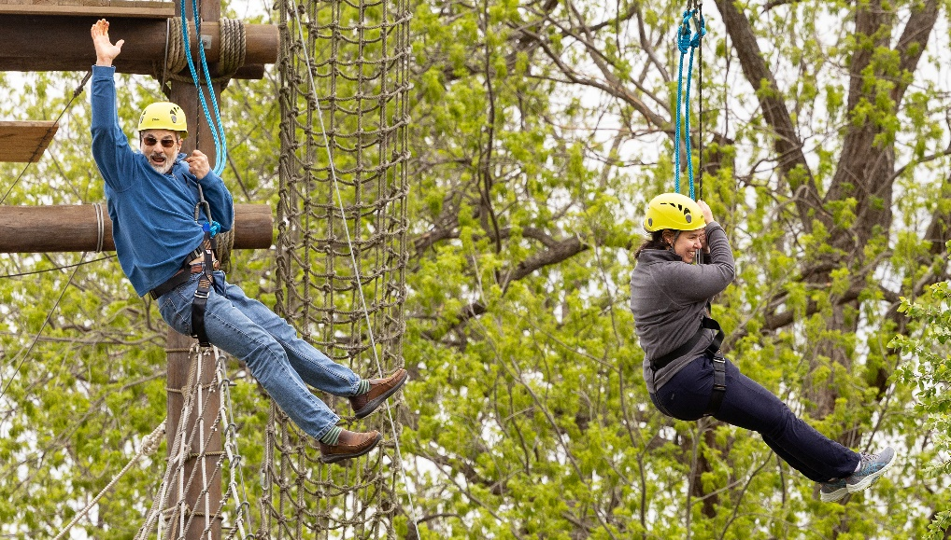  The Blount Recreational Sports Complex features multipurpose fields for football, soccer, and softball, ideal for intramural leagues or casual pick-up games.  Ready to take the next step toward a healthier you?  Learn more about membership options for the whole family, fitness classes, and facility hours by visiting the Campus Recreation & Wellness webpage.  ECU also offers services to support employee well-being in five key areas: career, social, financial, physical, and community. Key to this support is the Faculty and Staff Assistance Program (FASAP), offered through ComPsych.
 | Find Your Way #1: Canvas Connections  If you are new to Canvas (or just want to refresh your skills), check out the virtual Canvas Connections series hosted by the Learning Technologies team. These sessions are geared toward new faculty and start July 2 and run through July 28. Lasting just 15 to 30 minutes, each session is an opportunity to see a demonstration of some of the powerful tools available in Canvas and learn how to get started using them in your course.  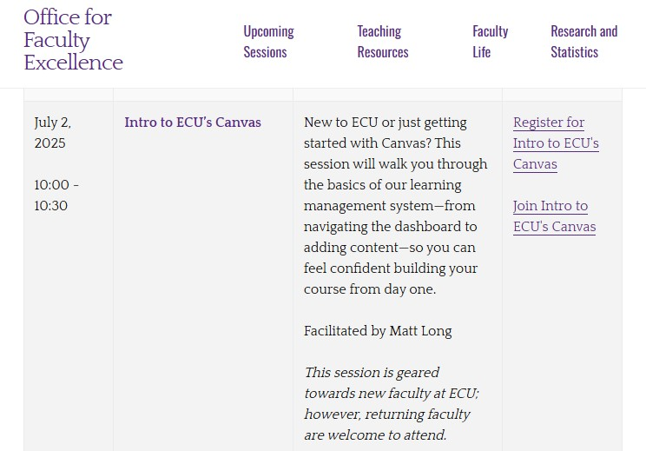

Find Your Way #2: Purchasing Parking Permits
If you plan to be on campus regularly, you will need a parking permit! You can access parking information through PiratePort. Once there, select Parking and Transportation to reach the Parking Portal. As a new employee, you are eligible to purchase a B1 permit or Garage Access. Permits for A1 lots are allocated from a waitlist. It can take a few years to receive an A1 permit, so we recommend signing up now!

Not sure where to park? Check out this map to find the closest lot to your building. Note that ECU uses a Plate-to-Permit system - you will not receive a physical parking permit.

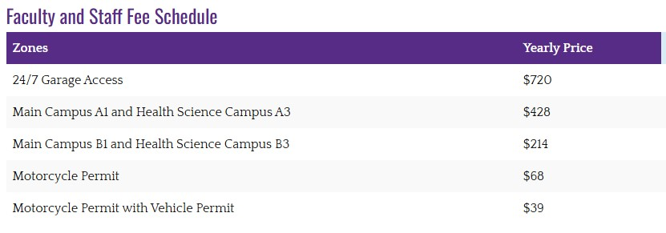

Find Your Way #3: ECU Alerts and LiveSafe

Want to be the first to know when something important happens? Register for ECU Alerts and get official updates about emergency procedures and hazardous weather, sent straight to your phone and computer.

For an extra layer of safety, download the LiveSafe App to your phone. LiveSafe gives you a direct line to ECU Police and lets you send texts, photos, videos, and even start a live chat when you need help.

Curious how it works? Click on the video below to hear from the ECU Police Department as they walk you through the LiveSafe App and show you all its powerful features.
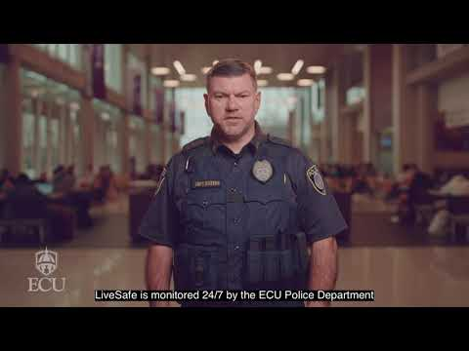
 | Find Your Spot: Popular Day Trips  We think Greenville is pretty great, but when you’re ready for a change of scenery, there is no shortage of adventures nearby!  Craving a beach day? Emerald Isle, part of the stunning Crystal Coast, is less than two hours away. With oceanfront and sound front access, festivals all along the coast, and the chance to spot a sea turtle or two (from a respectful distance — they’re protected!), it’s the perfect place to grab a chair, pop open an umbrella and get some Vitamin Sea.  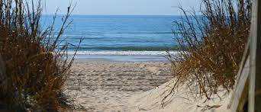  Prefer to stay closer to town? Head over to Washington, NC, colloquially known as “Little Washington.” Just 30 minutes away, this Pamlico River town offeres everything from water sports to historic walking tours and shopping to hiking in Goose Creek State Park.  If professional sports are more your thing, you’re in luck! Raleigh (about 90 miles away) is home to some of North Carolina’s top teams: the NHL Hurricanes (ice hockey), Durham Bulls (minor league baseball), and the NC Courage (women’s soccer).
 | Find Your Purpose: Mentoring at ECU  At ECU, you are never alone. We know how vital it is to have strong mentoring, especially as a new faculty member, and we’re committed to helping you build those connections. Take a look at the video below where Dr. Eboni Baugh walks you through a mentor map to get you started on the right foot.  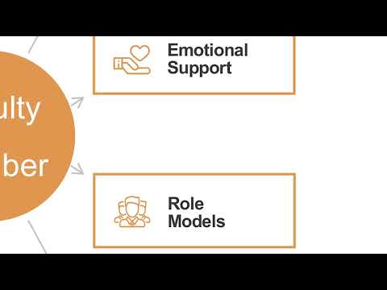  We encourage you to start thinking about who might be a good fit for your mentor map. No need to rush – this is a process and your mentor map will grow with you. Remember, we’re here to support you every step of the way.  Download a fillable version of the mentoring map.
Directions to websites in this newsletter:
- Eakin Student Recreation Center
- Eakin Student Recreation Center Video Tour
- Health Sciences Campus Recreation Complex
- Health Sciences Complex Virtual Tour
- North Recreational Complex
- Blount Recreational Sports Complex
- Campus Recreation & Wellness
- ECU Employee Well-being
- Faculty and Staff Assistance Program
- Canvas Connections series
- PiratePort
- Parking and Transportation
- ECU Parking Map
- ECU Parking Faculty and Staff Webpage
- Register for ECU Alerts
- LiveSafe App Help Video
- Visit Emerald Isle
- Visit Washington, NC
- Explaining the mentoring map
- Fillable version of the mentoring map
- New Faculty Orientation Information Survey Link

You can visit the NFO 2025 Find Your Fit website to view the newsletters released each week, as well as access previously released content. If you haven’t filled out the NFO 2025 Survey, please help us plan for our August gathering!
Please reach out if you have any questions by replying to this email or emailing ofe@ecu.edu. Stay tuned for next week’s newsletter!
-The New Faculty Orientation (NFO) 2025 Team!

