

New Faculty Orientation 2025 - Newsletter #3

In this edition learn more about the University Writing Program and Writing Across the Curriculum, as well as Universal Design for Learning (UDL). You’ll also get information about the academic calendar, creating course syllabi, and selecting a textbook for your course.  - NFO 2025 Team | Find Your Support:  University Writing Program  Writing Across the Curriculum  Find Your Way:  Academic Calendar  Selecting Textbooks  Course Syllabus  Find Your Purpose:  Universal Design for Learning

New Information for June 19:
 | Find Your Support: University Writing Program & Writing Across the Curriculum  At ECU, we know writing is at the heart of your work as a faculty member. That’s why the University Writing Program and Writing Across the Curriculum are here to support you. Join Dr. Kerri Flinchbaugh as she shares how these programs can make your writing and teaching journeys a little easier by clicking the video below.  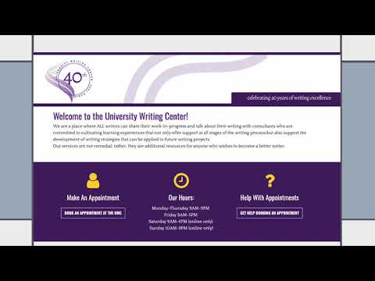  The Writing Across the Curriculum (WAC) Academy is a six-week institute held each spring semester. Interested in learning more? Reach out to Dr. Kerri Flinchbaugh (flinchbaughk@ecu.edu) or Dr. Will Banks (banksw@ecu.edu).
 | Find Your Way #1: Academic Calendar  Essential to planning your semester and developing your syllabus, the academic calendar is key to course success. ECU provides 15-week and 8-week Alternate Block/Flight Path courses each term, so be sure you use the right calendar for the course you are teaching!  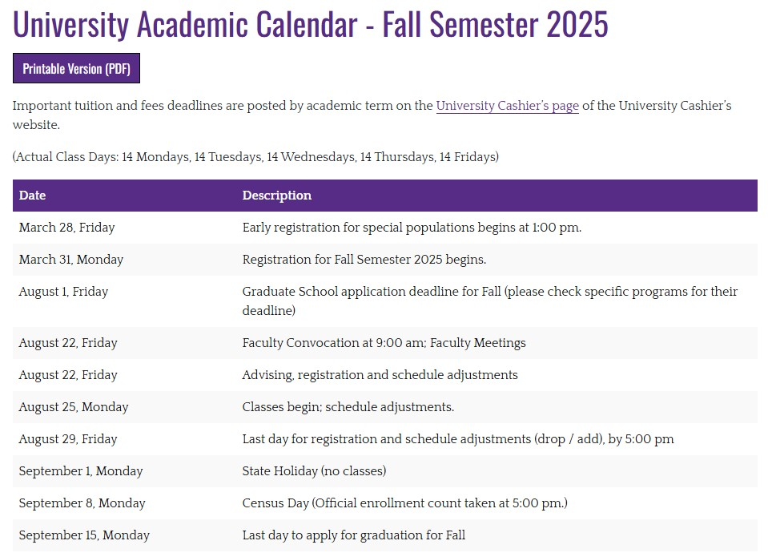

Find Your Way #2: Selecting Textbooks

Textbooks are usually selected the semester before a course is taught, so it is a good idea to check with your unit administrator (chair or director) to see if one has already been chosen for your course. Some departments use the same textbook across all sections, so if you’re not sure, your unit administrator is the best person to ask.

When it’s time to submit a textbook, faculty use the Adoption & Insights Portal (AIP) associated with the ECU Bookstore (Dowdy Student Stores) to record that selection for students. After you are officially assigned to your courses, you’ll get a personalized email from the ECU Bookstore with instructions for submitting your textbook adoption (if one hasn’t already been submitted).

Find Your Way #3: Developing Course Syllabi

Creating course syllabi at a new institution, especially if you’re new to teaching, can feel overwhelming, but you’re not on your own. ECU has plenty of resources to guide you! The ECU Faculty Manual outlines the required information that must be shared with students in your syllabus, but you are welcome (and encouraged) to go beyond those basics. Dive into OFE’s Syllabus Resources page and the Faculty Manual to get started. Your college and/or department may have additional tools or templates to support you.

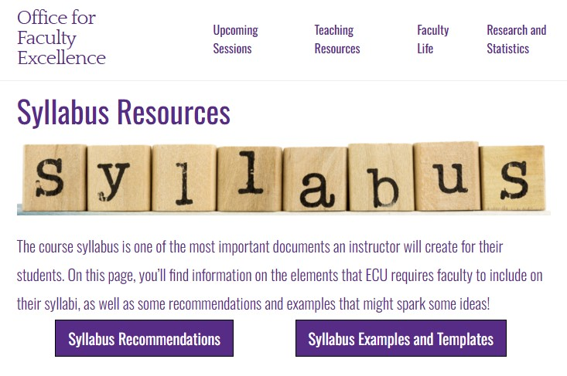

Since we are highlighting textbooks in this issue, here are some helpful details to include in your syllabus:

Title
Author(s)
ISBN
Specific edition required
Picture of textbook cover

Important! Some departments require a standardized syllabus format. We recommend checking with your unit administrator to see if there is a template you should be using
 | Find Your Purpose: Universal Design for Learning (UDL)  Universal Design for Learning (UDL) is an approach that meets students where they are, embracing the variability that comes with every classroom. In the video below, Justin Littlefield shares how to plan engaging learning experiences that help all students grow and succeed.  UDL is guided by three principles that ensure learners have access to multiple means of engagement:  - Gaining and maintaining learner engagement  - Representing information and portraying knowledge  - Optimizing physical action and expression options  Watch to see how you can start weaving these principles into your courses by clicking on the image below.  
Directions to websites in this newsletter:
- University Writing Program
- Writing Across the Curriculum
- Academic Calendar
- ECU Bookstore (Dowdy Student Stores)
- OFE Syllabus Resources
- Faculty Manual
- Universal Design for Learning
- UDL with Justin Littlefield
- New Faculty Orientation Information Survey Link

You can visit the NFO 2025 Find Your Fit website to view the newsletters released each week, as well as access previously released content. If you haven’t filled out the NFO 2025 Survey, please help us plan for our August gathering!
Please reach out if you have any questions by replying to this email or emailing ofe@ecu.edu. Stay tuned for next week’s newsletter!
-The New Faculty Orientation (NFO) 2025 Team!

