

New Faculty Orientation 2025 - Newsletter #2

In our second newsletter, we provide a sneak peek of NFO topics and opportunities. You’ll also get information about Joyner Library and Laupus Library, take a virtual tour of ECU, and learn more about Town Common and other popular Greenville parks.  - NFO 2025 Team | Find Your Support:  Joyner Library  Laupus Library  Find Your Way:  NFO Basics  ECU Virtual Tour  Find Your Spot:  Town Common & Other Parks

New Information for June 12:
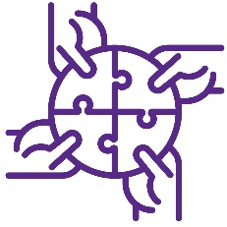 | Find Your Support: Joyner Library  ECU is home to three libraries. On the main campus we have a Music Library and Joyner Library. On the health sciences campus we have Laupus Library. Learn more about Joyner and Laupus Libraries below.  Home to a host of resources, exhibits, and special collections, Joyner Library is a central gathering place on Main Campus. In addition to serving as the central repository for ECU records of permanent historical value, Joyner Library also houses the Rare Book and Digital collections (among others). Located on the second floor, the Janice Hardison Faulkner Gallery showcases art by ECU faculty and students. Joyner also offers a range of faculty support services for both instruction and research.  Enjoy this video overview with David Hisle as he shares more about Joyner Library.  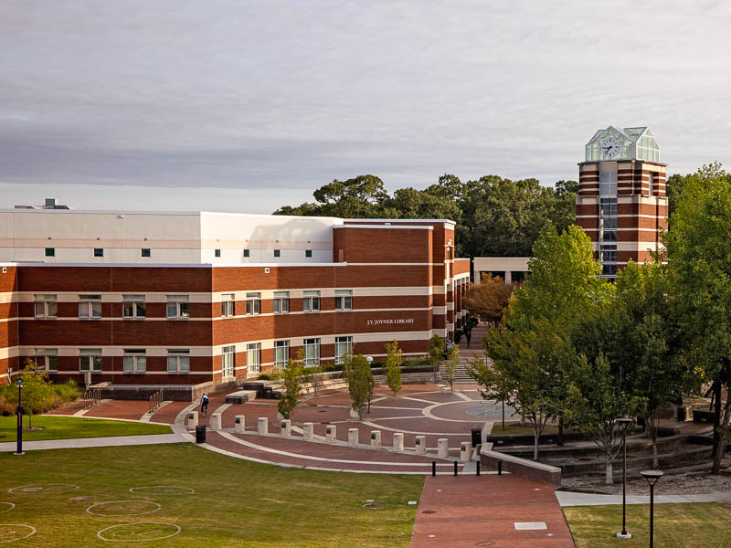

Find Your Support: Laupus Health Sciences Library

Located on the Health Sciences campus, the Laupus Health Sciences Library provides resources for Allied Health Sciences, Dental Medicine, Medicine, and Nursing. Librarians are available to provide curricular and research support, including embedded assistance with Canvas courses, teaching orientations to the literature, and co-authoring systematic reviews.

Laupus Library also features History Collections relevant to the history and practice of health care in eastern North Carolina, including the County Doctor Museum, and a lecture series for the Medical History Interest Group.
Learn more about Laupus Library from Beth Ketterman.

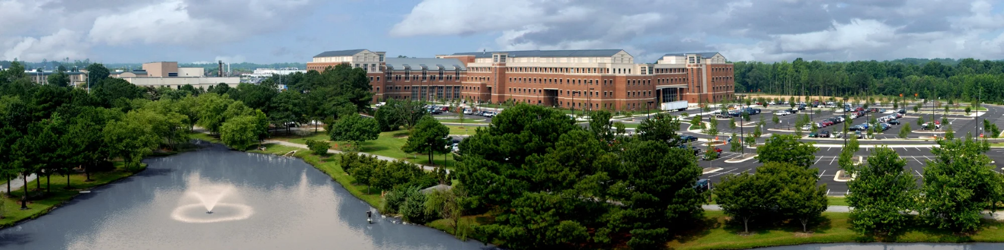
 | Find Your Way #1: Sneak Peek at New Faculty Orientation 2025  Like the name implies, New Faculty Orientation (NFO) is an opportunity for new faculty from across the university to come together for an informative and engaging two-day orientation event. Right now, you can do three things to prepare:  - Mark your calendars!  8:00 am to 7:00 pm on Monday, August 18th  8:00 am to 5:00 pm on Tuesday, August 19th  Please plan to attend both days for the entire day.  Stay tuned for more information as we solidify the schedule. We’ll provide updates in future newsletters and on the NFO 2025 Find Your Fit website.  - Complete the New Faculty Orientation Information Survey by June 30th to help us plan.  - Get excited about meeting your new colleagues and getting started as a member of Pirate Nation!  The NFO agenda is packed with helpful information and resources to help you get started ECU. Topics include:  - Employee Benefits and Resources  - Support from ECU Libraries  - Teaching-related Assistance  - Infrastructure to Support Research  - Guidance on Supporting Students at ECU  - Faculty Policies, Processes, and Resources  - Building your Support System  - …and more!  NFO is not just about learning, however. It’s also packed with opportunities to connect with other new faculty and key people who help you chart a course for success on your ECU journey. During NFO, you will meet senior campus leaders, attend an information fair tailored to the needs of faculty, and attend break-out sessions that align with your specific interests.  We are looking forward to seeing you!

Find Your Way #2: Take a Tour of ECU

Haven’t had a chance to fully explore the university yet? Check out some highlights (or revisit your favorite spots) through this virtual tour of our beautiful campus.

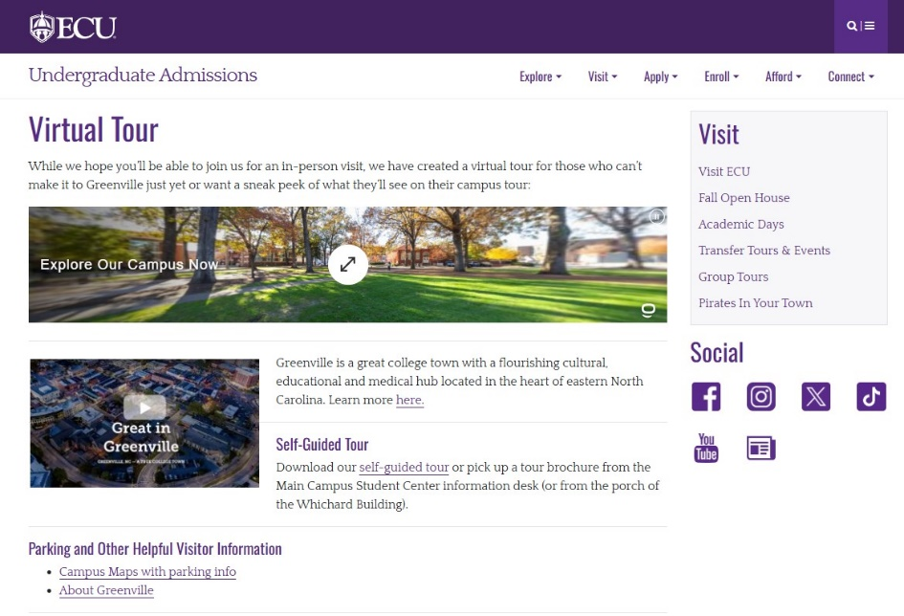
 | Find Your Spot: Explore Town Common and Other Popular Parks  If you love getting outside, you’re in luck! Greenville is home to 38 recreation and park facilities.  The Greenville Town Common is the heart of downtown, featuring an inclusive playground, 21 acres of green space, boat access, and miles of walkway and bridges alongside the Tar River. Home to a concert series, PirateFest, and other popular downtown events, the Town Common serves as a central hub for downtown Greenville.  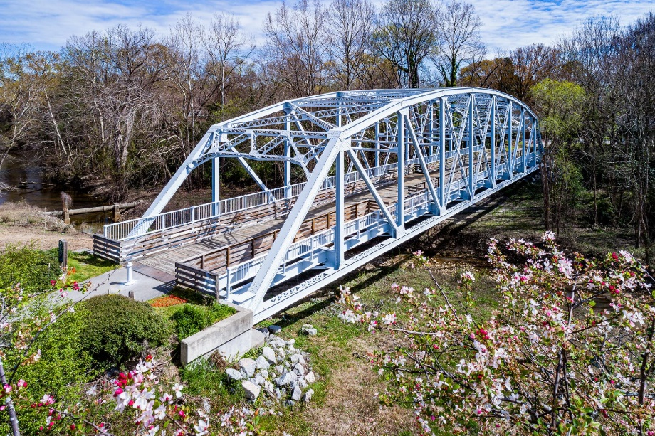  Prefer to go off-track? Wildwood Park has something for everyone, including several playgrounds, a bicycle skills and pump track, kayak launch, six miles of mountain bike trails, a walking trail, and more.  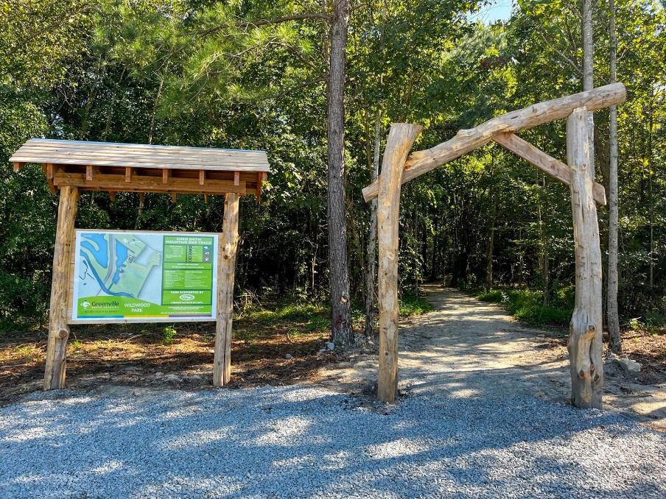  If you like to fish, River Park North has a boat ramp and boat rentals, fishing piers, and stocked ponds. It also features walking trails and a Science and Nature Center.  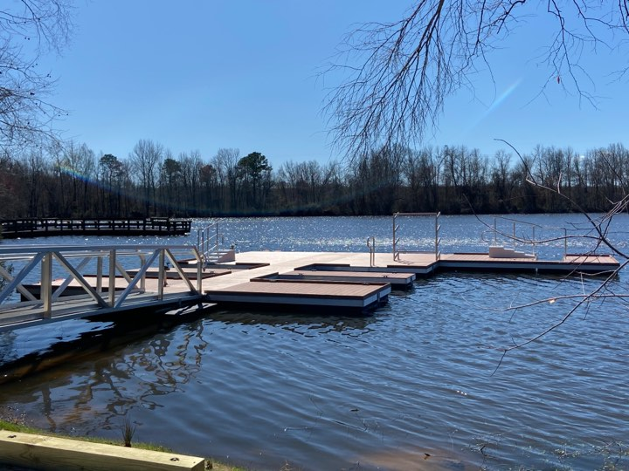
Directions to websites in this newsletter:
- Music Library
- Joyner Library
- Joyner Library Services for Faculty
- Laupus Health Sciences Library
- County Doctor Museum
- NFO 2025 Survey
- Virtual Tour of ECU
- Greenville Recreation and Parks
- Town Common
- Wildwood Park
- River Park North

You can visit the NFO 2025 Find Your Fit website to view the newsletters released each week, as well as access previously released content.
Please reach out if you have any questions by replying to this email or emailing ofe@ecu.edu. Stay tuned for next week’s newsletter!
-The New Faculty Orientation (NFO) 2025 Team!

